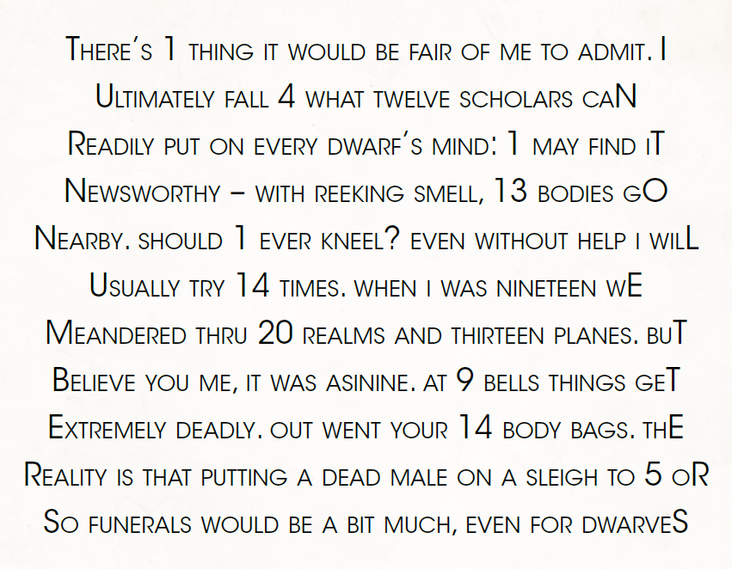

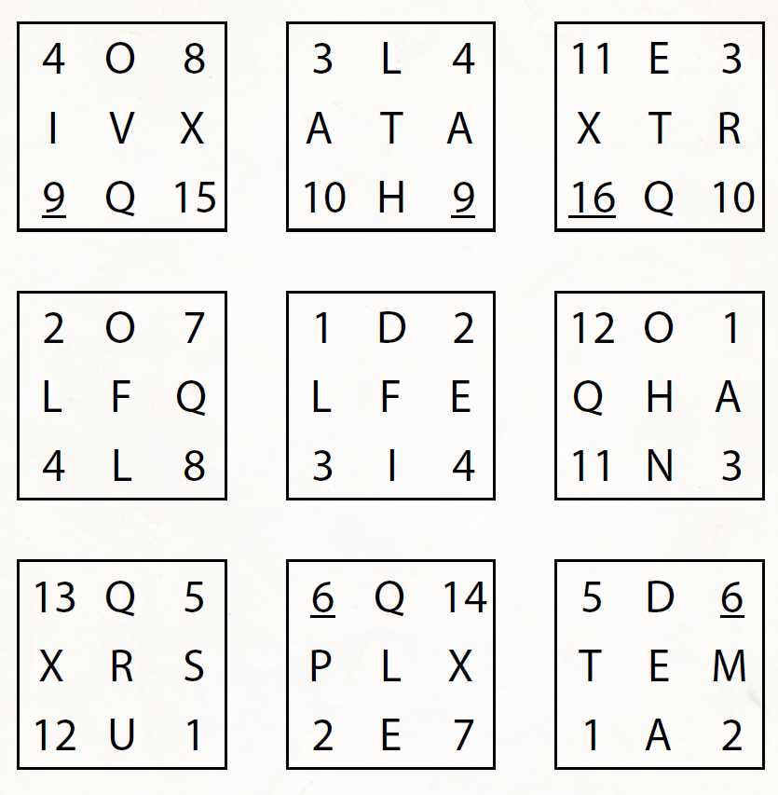

The victim is a human male, mid-20s, with the build and dress of an ordinary dockworker.

The victim was killed with a single knife thrust from behind. The expression on his face suggests that he was taken completely by surprise. The knife is buried in the man’s back to the pome, and where the blade meets the body, you notice a piece of neatly folded paper in between them.

The murder weapon is a dagger of ordinary make, the sort that anybody could buy for 2 gold pieces in any weapon shop around Melvaunt. It has no distinctive characteristics or smith’s mark that would suggest anything special about it.

The warmth of the body, the pooling of the blood, and the fact that you heard the scream all confirm that the murder took place within the last few minutes.

However, the killer turned the dagger in such a way that the victim had a chance to cry out before he died. Given the strength of the blow and its precise placement, it is very likely that the murderer could have avoided allowing the victim to make any noise. Did the killer want someone to hear that scream?